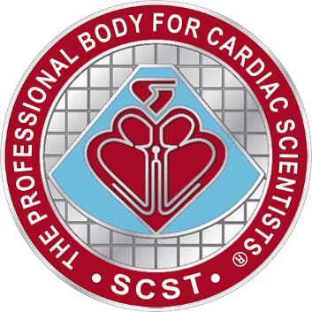
SCST NI Regional Scientific Meeting

When: Friday 5th June 2026, 10am – 3pm
Where (TBC): Lecture theatre, MDEC
Altagelvin Area Hospital, Glenshane Road, BT473
Agenda
10:15 – Registration
10.30 – Welcome and opening remarks - Gareth Clifford, Senior Chief CP, BHSCT, NI representative SCST Council
Clinical session
Introduction and opening – Chair, Pauline Cuskeran Lead Cardiac Physiologist WHSCT (Session chair)
10:45 – Percutaneous Coronary Intervention and current Practices - Dr Jack Andrews, Cardiac Consultant, WHSCT
11:15 – Left Bundle Branch Area Pacing and current followup practices– Joint talk Belfast & Southern trusts
12:00 – Case study/ Student presentation.
12:30 Lunch 30 mins

Professional session
13:00 - Introduction and opening – Chair, Dr. Nicole Blackburn, Course Director, Healthcare Science University Ulster.
13:15 – UKAS departmental accreditation – a roadmap to helping improve services. Laura Booth, Operations Accreditation Specialist (Healthcare)
14:15 – University of Ulster update on the Healthcare Science Degree and Post Graduate opportunities – Professor Daniel Kerr, Head of School of Health Sciences, Magee Campus.
15:00 – Closing Remarks – Ms P. Cuskeran (WHSCT)
15:15 Q&A & Course evaluation
Book a free space via the QR code >>
Sponsored by

