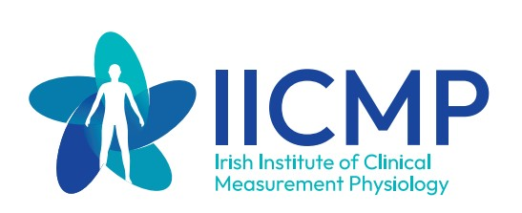

European Society for Vascular Surgery 37th Annual Meeting (26th – 29th September 2023)

To apply for IICMP funding please submit below Expression of Interest form to Karen Dobbyn at ProfessionalDevelopment@iicmp.ie by the 30th June 2023.

Expression of Interest Form

Please include the following details:
Name:
Job title:
Grade:
Name of Hospital:
IICMP Member: Yes/No
Outline if time off will be granted by your department -YES/NO
ESVS Member: YES/NO
Any other information that you wish to include:

-----------------------------------------------------

-----------------------------------------------------

